WELCOME TO HIGHFIELD SURGERY

To register with this practice, please complete this questionnaire as fully as possible. It can take some time for your previous medical records to reach us. The information you give in this questionnaire will help us to provide you with good medical care.

PERSONAL DETAILS
Title | Mr / Mrs / Miss / Ms | Have you been registered here before? |  |  | Yes No
Surname |  | Previous Name |  |  | Male Female
Forename(s) |  | Address
Date of Birth
NHS number
Home Tel: |  | Postcode:
Mobile: |  | Email:
Work Tel: |  | Occupation:
Name of School (if aged 12-18 years):
Emergency Contact Name: |  | Relationship: |  | Tel:
Next of Kin: |  | Relationship: |  | Tel:
Status | Single Married Separated Divorced Widowed Cohabiting

HEALTH DETAILS
Please use the automatic equipment in the waiting room to record you blood pressure.
Take the printed result to the Reception. (Adults only – BP not required for children)
Blood pressure | / |  | Height |  |  | Weight
Do you smoke? | Yes No |  |  |  | How many a day?
If yes, are you interested in giving up smoking? Yes No |  |  |  | Yes No
If not a smoker, have you ever smoked? Yes No |  |  |  | Yes No
If YES, when did you START? |  |  |  | When did you STOP?
How many per day? |  | Cigarettes: Cigars: Pipe:
Alcohol – Alcohol use can affect your health and interfere with certain medications and treatments. Your answers will remain confidential so please be honest.
Use the guide below to decide how many UNITS you drink a week.
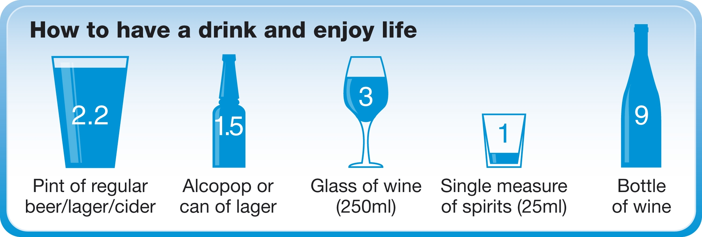 |  |  |  | Do you drink any alcohol? |  |  |  |  | Yes No
 |  |  |  | How many units / week?
 |  |  |  | Drugs
 |  |  |  | Do you have a drug  addiction? |  |  |  |  | Yes No
Exercise – Do you take exercise? |  |  |  | Yes No
On average, how many sessions of moderate or vigorous activity of twenty minutes or more duration do you usually do each week? |  |  |  | sessions

New Patient Questionnaire – 2

MEDICAL HISTORY
Do you have, or have you had, any serious health problems (including operations) or long-term conditions?
 |  | Details |  |  | Date (if known)
Asthma
Cancer
COPD
Chronic kidney disease
Diabetes
Epilepsy
Heart attack/disease
High blood pressure
High cholesterol
Osteoporosis
Stroke
Mental health problems
Underactive thyroid
Circulation problems
Other serious illness
Any operations
Any known allergies | Yes No If yes, please list.
Allergic to: |  |  | Type of reaction:
Allergic to: |  |  | Type of reaction:

REPEAT MEDICATION
Are you on any medicines at present? | Yes No
If you are on regular medication, please provide a recent printout (less than two months old) of your medication to Reception and we will arrange for the items to be set up on our clinical system.
If you do not have a printout, please ask for a doctor’s appointment to discuss this.
Do you take any other over-the-counter medication? If so please list:

ELECTRONIC PRESCRIPTION SERVICE (EPS)
The Electronic Prescription Service (EPS) is an NHS service. You will not have to visit the GP practice to pick up your paper prescriptions. Instead, your GP will send it electronically to your nominated Pharmacy. (An information sheet is included in your new patient pack with full details.)
Please indicate your preference below:
I would like my repeat prescriptions sent electronically to: | Pharmacy  Branch
I would prefer to collect my repeat prescriptions from the surgery

New Patient Questionnaire – 3

FAMILY MEDICAL HISTORY
Have any of your immediate relatives (brothers/sisters/parents) had any of the following:
 |  | Details | Relationship | Date (if known)
Heart attack or angina before age 60
Heart attack or angina over age 60
Asthma
Diabetes
Stroke
Cancer
Any inherited diseases

FEMALES ONLY
Date of last cervical smear? |  |  |  | Are you pregnant? |  |  | Yes No
Have you had a hysterectomy? |  |  |  |  |  |  | Yes No
Contraception – what is your current method of family planning?
None |  |  | Coil |  |  | Injection
Contraceptive Pill |  |  | Sterilisation |  |  | Implant
Condom |  |  | Partner had vasectomy |  |  | Hysterectomy

CARERS
Do you look after an elderly or sick relative or friend? | Yes No
If YES, please indicate relationship:
Would you like to be put in touch with the Carers Bucks who can offer practical help and support? | Yes No

Ethnicity – How would you describe your ethnicity?
White | British | Irish |  | Other white
Asian | Asian British | Bangladeshi |  | Indian |  | Pakistani | Other Asian
Black | Black British | African |  | Caribbean |  | Oher black
Mixed | Asian & White | Asian & Black |  | Asian & Caribbean |  | White African | White Caribbean
Other | Chinese | Japanese |  | Middle Eastern |  | Other (please state)
Country of Birth:
Do you speak English? |  |  | Yes No |  | First Language (if not English):

Appointments – please book the following appointments if applicable
If you have asthma / COPD | Appointment with Respiratory Nurse
If you have diabetes | Appointment with Diabetic Nurse
If you have heart disease | Appointment with Cardiac Nurse
If you want to quit smoking | Appointment with Nurse or Advice Leaflet

DATA SHARING

Communication within the NHS is important to ensure that those who are caring for you have enough information to treat you safely. Traditionally health professionals exchanged medical information through letters, but in the modern age of computers, electronic exchange of information has become increasingly commonplace.

Highfield Surgery takes responsibility for your confidential medical information very seriously. This form offers you the opportunity to express your wishes as to whether or not you would like your medical record to be shared. In addition you can consent to receiving reminder text messages and if you would like to access our online services.

PERSONAL DETAILS
Surname: |  | First Name |  | Date of Birth

SMS TEXT MESSAGING
Would you like to receive text message appointment reminders and other notices from Highfield Surgery? |  |  | Yes No
I consent to receiving appointment confirmations, reminders and other notices via text messages and will update the Surgery of any changes to my mobile number.
Signature |  | Date

SUMMARY CARE RECORD (SCR)
The NHS in England has introduced the Summary Care Record, which will be used in emergency care.
The record will only contain information about any medicines you are taking, allergies you suffer from and any bad reactions to medicines you have had to ensure those caring for you have enough information to treat you safely.
Your Summary Care Record will be available to authorised healthcare staff providing your care anywhere in England, but they will ask your permission before they look at it, if possible. This means that if you have an accident or become ill, healthcare staff treating you will have immediate access to important information about your health.
As a patient you have a choice. Please indicate your preference below:
For further information visit the website www.nhscarerecords.nhs.uk, or telephone the dedicated NHS Summary Care Record Information Line on 0300 123 3020.
Do you wish to have a Summary Care Record? |  |  | Yes No
Signature |  | Date

